Paths to a Healthier Child Care Workforce Toolkit

About the Toolkit
The purpose of this toolkit is to share helpful information regarding the Paths to a Healthier Child Care Workforce white paper and to help you reach your desired audiences on various channels including newsletters, social media posts, and blog posts.

LinkedIn/Blog/Newsletter Posts
Child Care Aware® of America recently released a new white paper, Paths to a Healthier Child Care Workforce, covering the health and wellness habits of child care workers employed in child care settings. The white paper is designed to identify child care workers’ perception of wellness, learn about work-related barriers to healthy active living, and explore ways to entice workers to participate in workplace and community-based wellness programs.
To gain perspective on health and wellness among child care workers, CCAoA staff conducted focus groups with child care workers to learn about their health status and any barriers they have to healthy active living.
Our focus groups revealed:
- Child care workers care for and promote the health and wellness of our nation’s children, but in doing so, struggle to make healthy choices for themselves.
- Child care workers desire to achieve and maintain optimum health and wellness for themselves; however, limited time, money, and access to healthy food and space/facilities for physical activity negatively impacts their ability to maintain healthy eating habits, physical activity routines, and stress management practices.
- The health and wellness concerns and needs are similar for center-based and family-based child care workers; however, the strategies to meet these needs differ.
Visit CCAoA’s website to read the Paths to a Healthier Child Care Workforce white paper, explore findings from our focus groups, and learn about strategies and recommendations for staff wellness.

Social Media

Facebook
Post Text: @USAChildCare discovered, via a recent focus group with #childcare workers, that money affects their nutrition and physical activity choices, and child care workers have limited income. The consensus was that healthy foods are expensive. Fresh fruits and vegetables generally cost more than canned or frozen, and they have a short shelf life. #workerwellness
Edit Page Title: (leave as-is)
Edit Page Description: (leave as-is)
URL: http://ow.ly/TpZM30aibov
Edit image: replace with <Barriers>
Post Text: : @USAChildCare discovered, via a recent focus group with #childcare workers, that time appears to be an issue for all child care workers, but especially those in family child care settings. Child care workers often work 12-hour shifts to accommodate working families whose children need care. After caring for children all day and coming home to responsibilities with their own families, many often cannot set aside time to prepare healthy meals or to take time to be active. #workerwellness
Edit Page Title: (leave as-is)
Edit Page Description: (leave as-is)
URL: http://ow.ly/TpZM30aibov
Edit image: replace with <Barriers>
Post Text: Research in other industries has shown that worksite wellness programs not only positively impact the health and wellness of employees, but also result in benefits to the employer (e.g., reduced absence due to illness, increased job satisfaction). #workerwellness
Edit Page Title: (leave as-is)
Edit Page Description: (leave as-is)
URL: http://ow.ly/TpZM30aibov
Edit image: replace with <Opportunities>
Post Text: Many child care workers put in 10- to 12-hours of work, five days per week. This leaves little time or energy for personal and family responsibilities and activities. Family child care providers acknowledged that the long and often unusual hours (e.g., nighttime care) are necessary to meet the needs of the families they serve. #workerwellness
Edit Page Title: (leave as-is)
Edit Page Description: (leave as-is)
URL: http://ow.ly/TpZM30aibov
Edit image: replace with <Scale>

Post Text: @USAChildCare recently conducted a focus group with #childcare workers on the topic of health. Paths to a Healthier Child Care Workforce covers their health and wellness habits. The white paper is designed to identify child care workers’ perception of wellness, learn about their work-related barriers to healthy active living, and explore ways to entice workers to participate in workplace and community-based wellness programs. #workerwellness
Edit Page Title: (leave as-is)
Edit Page Description: (leave as-is)
URL: http://ow.ly/TpZM30aibov
Edit image: replace with <White Paper>
Post Text: @USAChildCare recently conducted a focus group with #childcare workers on the topic of health. Paths to a Healthier Child Care Workforce covers the health and wellness habits of child care workers. The white paper identifies child care workers’ perception of wellness discusses work-related barriers to healthy active living, and explores ways to entice workers to participate in workplace and community-based wellness programs. #workerwellness
Edit Page Title: (leave as-is)
Edit Page Description: (leave as-is)
URL: http://ow.ly/TpZM30aibov
Edit image: replace with <White Paper>
Post Text: Read the Paths to a Healthier Child Care Workforce white paper to explore findings from the @USAChildCare focus groups and to learn about strategies and recommendations for #childcare staff wellness. #workerwellness
Edit Page Title: (leave as-is)
Edit Page Description: (leave as-is)
URL: http://ow.ly/TpZM30aibov
Edit image: replace with <White Paper>

Twitter
Money affects nutrition and physical activity choices, and #childcare workers have limited income #workerwellness http://ow.ly/TpZM30aibov <Barriers>
Fresh fruits & vegetables generally cost more than canned or frozen, and have a short shelf life #workerwellness http://ow.ly/TpZM30aibov <Barriers>
Child care workers often work 12-hour shifts to accommodate working families who need child care #workerwellness http://ow.ly/TpZM30aibov <Barriers>
Most centers don’t have space onsite for workers to be physically active #workerwellness http://ow.ly/TpZM30aibov <Barriers>
In addition to long hours, child care workers may not have designated lunch hours or break times #workerwellness http://ow.ly/TpZM30aibov <Barriers>
Wellness programs increase health and wellness of employees & also result in benefits to employers #workerwellness http://ow.ly/TpZM30aibov <Opportunities>
Wellness programs should focus on eating well, physical activity, managing stress #workerwellness http://ow.ly/TpZM30aibov <Opportunities>
#Childcare workers put in 10-12 hours daily – leaving little time for their own health #workerwellness http://ow.ly/TpZM30aibov <Scale>
Caring for their own children prevents #childcare workers from having time to prepare a quality meal #workerwellness http://ow.ly/TpZM30aibov <Scale>
A recent @USAChildCare paper covers the health/wellness habits of #childcare workers #workerwellness http://ow.ly/TpZM30aibov <White Paper>
A @USAChildCare paper identifies #childcare workers’ perceptions of wellness & healthy active living #workerwellness http://ow.ly/TpZM30aibov<White Paper>
Read this @USAChildCare paper exploring strategies/recommendations for #childcare staff wellness #workerwellness http://ow.ly/TpZM30aibov <White Paper>

Images

Barriers
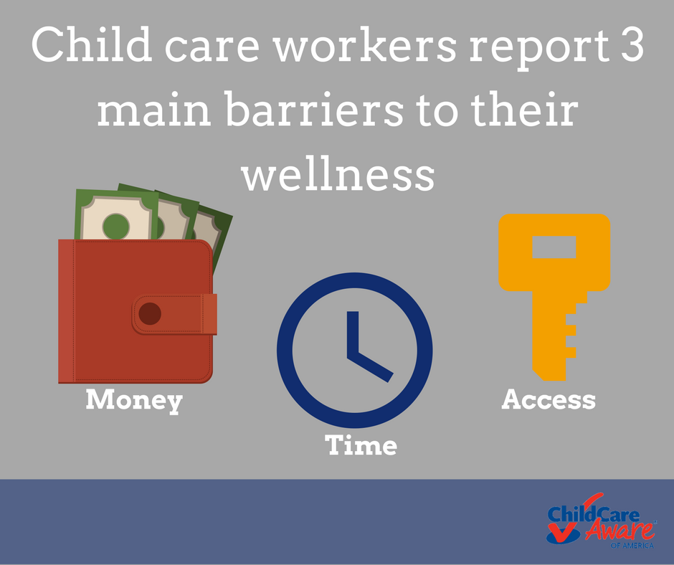

Opportunities
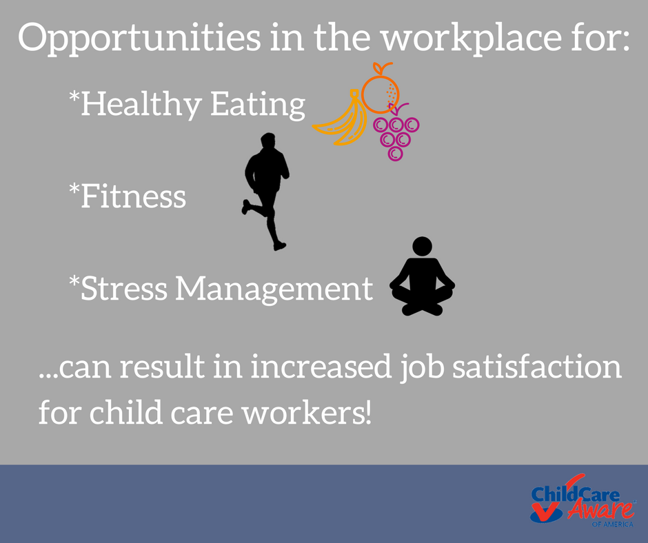

Scale
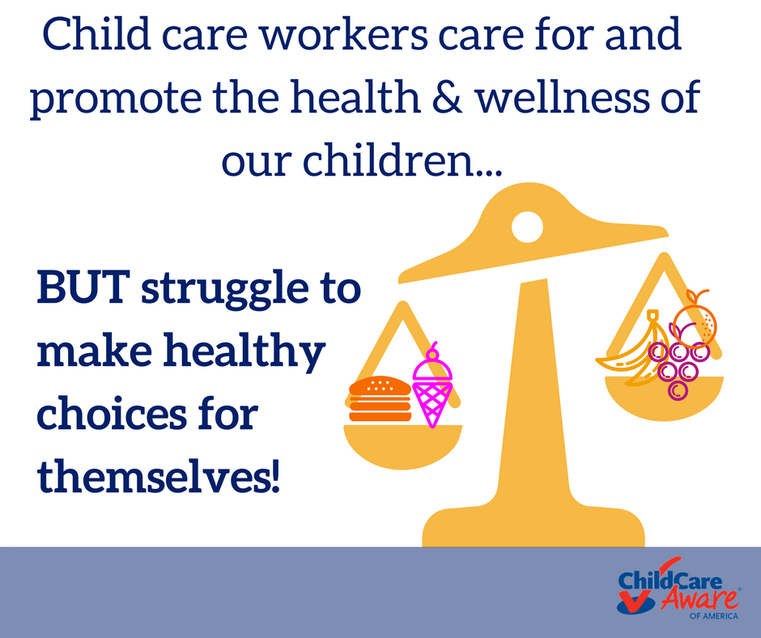

White Paper
