2017 Millennial Map Toolkit

About the Toolkit
The purpose of this toolkit is to share key messaging from our 2017 Millennials and the High Cost of Child Care Story Map to help us get the word out about the high cost of child care for millennial parents.

LinkedIn/Blog/Newsletter Posts
The cost of child care varies widely from state to state, but the median income for millennials is near poverty levels across the country. Explore the story map to learn more about the issues facing millennial parents as well as a nationwide examination of the affordability of full-time center-based care for an infant and of full-time center-based care for two children.

<Insert any graphic below>

http://usa.childcareaware.org/millennial-map/

Key Findings
- Child care is simply not affordable for millennial parents (those born between 1980 and 1997). The government standard for affordable child care fees set by the Department of HHS is under 7 % of family income but across all states, the average cost of center-based infant child care exceeds 25% of the average median income for millennials – with MA costing 68%.
- In seventeen states and DC, it takes at least 50% of a millennial’s income to pay for infant child care in a center. There are only 7 states where millennial parents are paying 30% or less of their income – and that is still very high!
- In 28 states plus the District, a year of tuition at a public university is more affordable than center-based infant care for millennials.
- For millennial parents with two children (one infant and one preschooler), they need at least 45% of their income to pay for child care costs, with Massachusetts millennials needing 119% of their income to pay for two children in child care.

Social Media

Twitter
Explore an interactive map via @USAChildCare regarding #millennialparents and the high cost of care http://ow.ly/Rhvq309Tzhf <Any graphic below>

Massachusetts millennials need 119% of their income to pay for two children in #childcare @USAChildcare http://ow.ly/Rhvq309Tzhf <Income or Average Income>

#Millennialparents w/2 children need at least 45% of their income to pay for #childcare costs @USAChildcare http://ow.ly/Rhvq309Tzhf <Income or Average Income>

Cost of center-based infant #childcare is >25% of the median income for #millennialparents @USAChildcare http://ow.ly/Rhvq309Tzhf <Income>

In 17 states & DC, it takes 50% of millennial’s income to pay for infant #childcare in a center #millennialparents @USAChildcare http://ow.ly/Rhvq309Tzhf <Unaffordable>

There are only 7 states where #millennialparents are paying less than 30% of their income @USAChildcare http://ow.ly/Rhvq309Tzhf <Unaffordable>

Millennials are the 1st to have higher poverty rates/lower incomes than their 2 preceding generations @USAChildcare http://ow.ly/Rhvq309Tzhf <Unaffordable>

In 28 states/DC, 1 year tuition is more affordable than center-based infant care for millennials @USAChildcare http://ow.ly/Rhvq309Tzhf <Undergraduate>

#Childcare is simply not affordable for #millennialparents (born between 1980-2000) @USAChildcare http://ow.ly/Rhvq309Tzhf <17 States>

Facebook
Post Text: #Childcare is simply not affordable for Millennial parents (those born between 1980 and 1997). The government standard for affordable child care fees set by HHS is under 7 % of family income but across all states, the average cost of center-based infant child care exceeds 25% of the average median income for millennials – with MA costing 68%. Find out more about #millennialparents and how they are affected by the high cost of child care via @USAChildCare:
Edit Page Title: (leave as-is)
Edit Page Description: (leave as-is)
URL: http://usa.childcareaware.org/millennial-map/
Edit image: replace with <Unaffordable or 17 States> (toward the end of the toolkit)

Post Text: Millennials are the 1st generation in modern history to have higher poverty rates and lower incomes than their two preceding generations. Further, it is reported that approximately 88% of student parents are living at or below 200% of the Federal Poverty Line. Find out more about #millennialparents and how they are affected by the high cost of #childcare via @USAChildCare:
Edit Page Title: (leave as-is)
Edit Page Description: (leave as-is)
URL: http://usa.childcareaware.org/millennial-map/
Edit image: replace with <Average Income> (toward the end of the toolkit)

Post Text: In seventeen states and DC, it takes at least 50% of a millennial’s income to pay for infant #childcare in a center. There are only 7 states where #millennialparents are paying 30% or less of their income – and that is still very high! Find out more via an interactive millennial map provided by @USAChildCare:
Edit Page Title: (leave as-is)
Edit Page Description: (leave as-is)
URL: http://usa.childcareaware.org/millennial-map/
Edit image: replace with <Average Income or Income> (toward the end of the toolkit)

Post Text: In 28 states plus the District, a year of tuition at a public university is more affordable than center-based infant care for millennials. Explore more via an interactive map about #millennialparents by @USAChildCare:
Edit Page Title: (leave as-is)
Edit Page Description: (leave as-is)
URL: http://usa.childcareaware.org/millennial-map/
Edit image: replace with <Undergraduate> (toward the end of the toolkit)

Post Text: For millennial parents with two children (one infant and one preschooler), they need at least 45% of their income to pay for #childcare costs, with Massachusetts millennials needing 119% of their income to pay for two children in child care. Find out more about #millennialparents and how they are affected by the high cost of child care via @USAChildCare:
Edit Page Title: (leave as-is)
Edit Page Description: (leave as-is)
URL: http://usa.childcareaware.org/millennial-map/
Edit image: <Average Income or Income> (toward the end of the toolkit)

Images and Graphics

Unaffordable
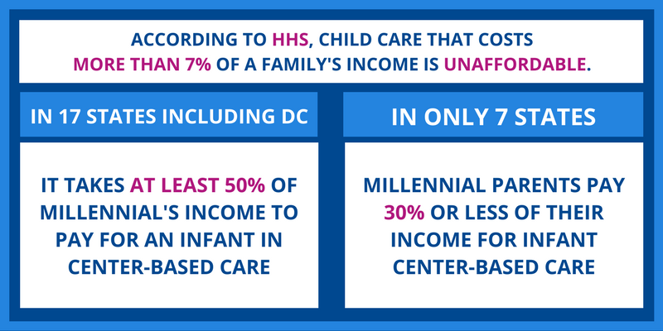

Income
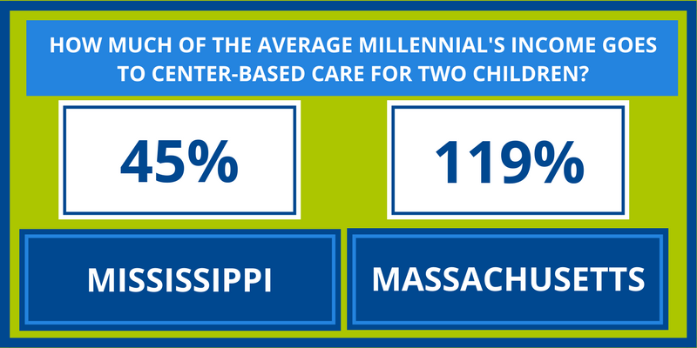

Average Income
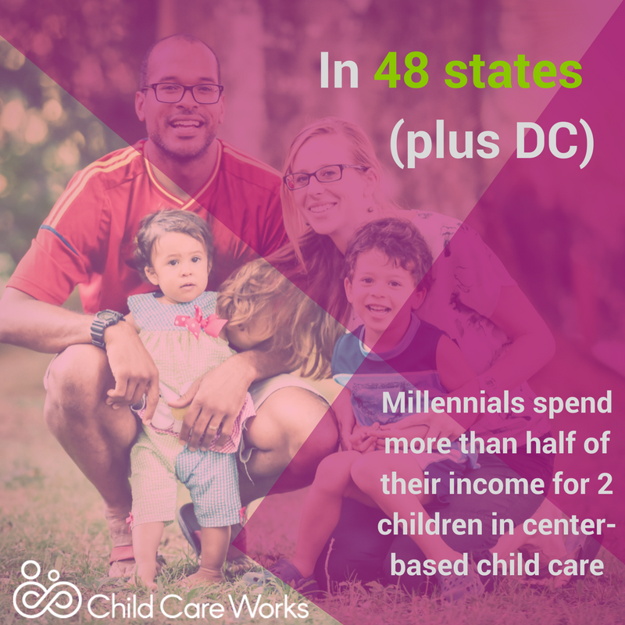

Undergraduate
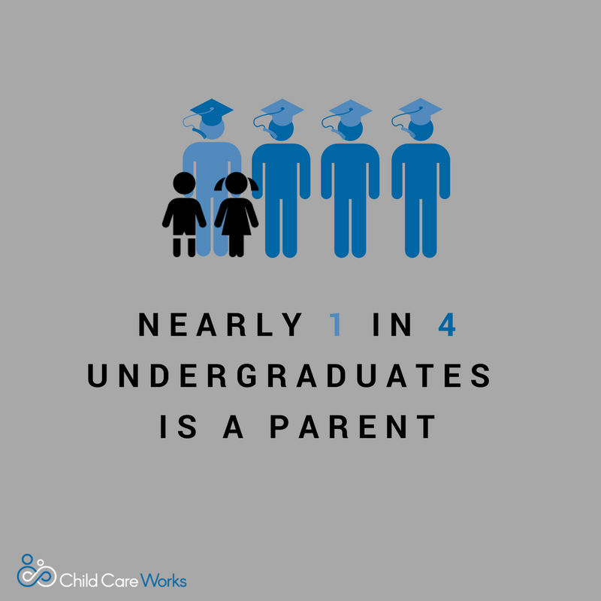

17 States
