Social Media Share Kit
Supporting Children Who Are Experiencing Stress

- Facebook
- Twitter
- Instagram
- Graphics (included throughout)
*To use one of the graphics, right click on the image and select “save as picture.” Save to your own computer, then upload to your social media post.

Facebook
POST 1: Post graphic first:
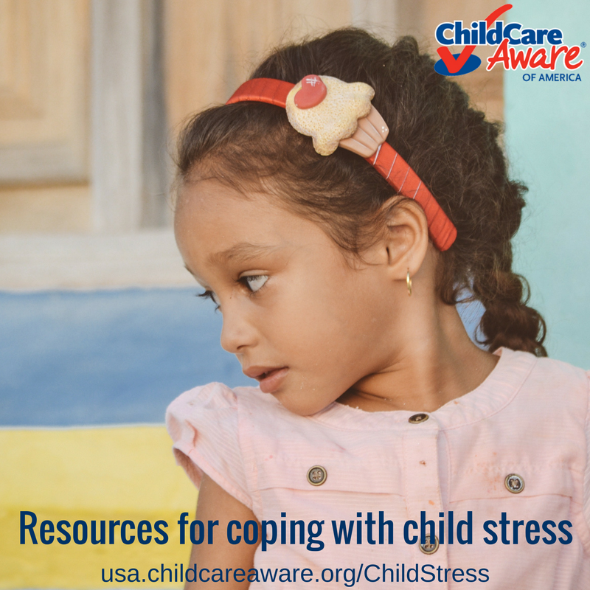
Text: New resources from Child Care Aware® of America (@USAchildcare) on how to help children deal with stress.
URL: http://usa.childcareaware.org/childstress
POST 2: Post graphic first:
Text: With everything going on in the world today, children can internalize a lot of stress. Learn how to recognize the signs, and how to help children cope with stress using resources from Child Care Aware® of America (@USAchildcare).
URL: http://usa.childcareaware.org/childstress
POST 3: Post graphic first:
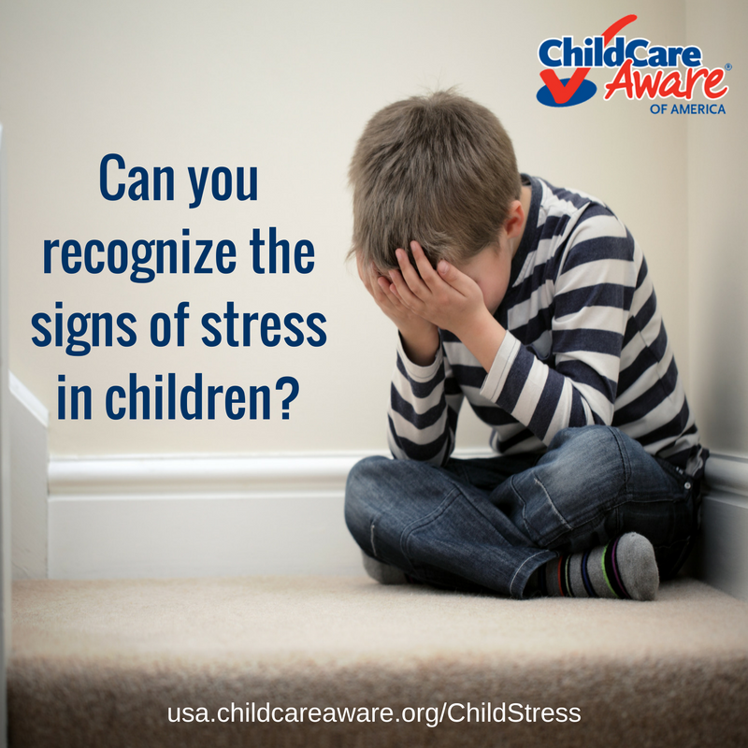
Text: Learn how to recognize signs of stress in children, and what you can do to help them cope, using a new resource from @USAchildcare: http://usa.childcareaware.org/childstress

Twitter
POST 1: Resources from @USAchildcare for #ChildCare providers on supporting children experiencing #stress: http://usa.childcareaware.org/childstress #mentalhealth <insert image below in tweet>

POST 2: Responding to children experiencing #stress: http://usa.childcareaware.org/childstress #childhealth #mentalhealth #ChildCare #parenting <insert image below in tweet>
POST 3: Recognize the signs of #stress in children, and how to help: http://usa.childcareaware.org/childstress #childhealth #mentalhealth #ChildCare #parenting <insert image below in tweet>

Instagram
POST 1: Resources from @USAchildcare for parents and child care providers on supporting children experiencing stress at http://usa.childcareaware.org/childstress
#childhealth #mentalhealth #stress #parenting #health #ChildCare
POST 2: @USAchildcare has resources on responding to children experiencing stress at http://usa.childcareaware.org/childstress
#childhealth #mentalhealth #ChildCare #parenting #stress #health
POST 3: It’s important to know how to recognize the signs of stress and trauma in children, and how you can help. Check out these resources from @USAchildcare at http://usa.childcareaware.org/childstress
#childhealth #mentalhealth #ChildCare #parenting #stress #health

