Social Media Messages: Health, Nutrition, Physical Activity
This toolkit was designed to provide sample posts for social media that showcase articles and information about the importance of having states support high quality health, nutrition and physical activity in child care settings, a letter to the editor to help inform the public about the importance of state child care plans and to help the public participate in the public hearing process for child care state plans. We encourage all to use these items to create awareness and education or advocacy campaigns around quality initiatives.
Some of the posts refer to state specific documents and require insertion of state specific links to the state administrator’s webpage—reach out to us if you have questions on how to use these tools or to show us how you have used these tools in your state!
To use the text in your social media posts, copy and paste into the platform. To use the images provided, right click on the image and select "Save As Picture." Then upload the image to your post in the platform.

Health
Facebook Posts
Post text: What healthy children need: nutritious food, physical activity—and sleep. Does your state’s proposed Child Care Plan support health needs of young children? Find the plan at ________________________. (I would only put the URL in the post text if it’s short and pretty. Otherwise I’d embed it and remove the URL from the messaging itself.)
URL: _____________
Post text: What healthy children need: nutritious food, physical activity—and sleep. Learn about the sleep needs of children ages birth through 5.
URL: http://kidshealth.org/parent/general/sleep/sleep.html#
Post text: Ssshhh, let baby sleep—up to 18 hours a day! Find out more about the sleep needs of young children >
URL: http://kidshealth.org/parent/general/sleep/sleep.html#
Post text: Young children’s brains and bodies need sleep in order to grow and develop. Learn why kids need lots of it!
URL: http://kidshealth.org/kid/stay_healthy/body/not_tired.html
Post text: Healthy habits begin early for children. Encourage your children to drink water!
Post URL: https://healthykidshealthyfuture.org/5-healthy-goals/provide-healthy-beverages/
Post text: Juice drinks are out, H₂O is in! Why water should be the beverage of choice for young children >
Post URLhttps://healthykidshealthyfuture.org/5-healthy-goals/provide-healthy-beverages/
Post text: What are the healthiest drinks for young children? Find out here.
URL: https://healthykidshealthyfuture.org/5-healthy-goals/provide-healthy-beverages/

Twitter posts
#Healthykids need nutritious food, physical activity - and sleep! Does your state’s Child Care Plan mention health? <shortened URL>
Healthy children need nutritious food, physical activity—and sleep. #Sleep needs for birth through 5: http://ow.ly/WdRgz #childhealth
Ssshhh, let baby #sleep—up to 18 hours a day! More about the sleep needs of young children > http://ow.ly/WdRnB #childhealth
Young brains and bodies need sleep to grow and develop! What sleep is and why kids need lots of it: http://ow.ly/WdRzC #childhealth
Healthy habits begin in early childhood! How to encourage kids to drink water: http://ow.ly/WdRLb #childhealth
Juice drinks are out, H2O is in! Why water should be the beverage of choice for young children: http://ow.ly/WdRPY #childhealth
What are the healthiest beverages for young children? Find out: http://ow.ly/WdRUY #childhealth #nutrition

Nutrition
Facebook Posts
- Post text: Breastfed babies have lower risks of asthma, childhood obesity, and Type 2 diabetes. Find out other benefits of breastfeeding >URL: http://womenshealth.gov/breastfeeding/breastfeeding-benefits.html
Post title: Why breastfeeding is important

- Post text: Breastfeeding has health benefits for babies and mothers. Learn the facts!
URL: http://womenshealth.gov/breastfeeding/breastfeeding-benefits.html
Post title: Why breastfeeding is important

- Post text: Breastfeeding has health benefits for both babies and mothers. Learn the facts! URL: https://healthykidshealthyfuture.org/5-healthy-goals/support-breast-feeding/

- Post text: Breastfeeding has health benefits for babies and mothers. Does [state name]’s proposed Child Care Plan support breastfeeding for all? Check it out:
URL: ____________________
Post title: (State’s) Proposed Child Care Plan
Post description: TBD

- Post text: Child care settings should support women who want to breastfeed. Does your state’s child care plan support breastfeeding? Find out.
URL: ______________
Post title: (State’s) Proposed Child Care Plan
Post description: TBD

- Post text: The U.S. Department of Agriculture has proposed new nutrition standards for child care settings. Does [state name]’s proposed Child Care Plan back the new standards?
URL: ___________
Post title: (State’s) Proposed Child Care Plan
Post description: TBD

- Post text: Find out how child care providers can support moms who want to breastfeed.
URL: https://healthykidshealthyfuture.org/5-healthy-goals/support-breast-feeding/

- Post text: Healthy eating habits begin in early childhood. Get great tips on how to feed the kids in your care!
URL: https://healthykidshealthyfuture.org/5-healthy-goals/nurture-healthy-eaters/
- Post text: The U.S. Department of Agriculture has proposed new, improved nutrition standards for child care settings. Check out some important changes:
URL: http://www.pewtrusts.org/en/research-and-analysis/q-and-a/2015/03/fast-facts-on-raising-nutrition-standards-for-child-care-centers

- Post text: Healthy food fuels brain development in young children. Get best practices for serving up nutritious meals!
URL: https://healthykidshealthyfuture.org/5-healthy-goals/nurture-healthy-eaters/
Post title: (default)
Post description: (default)

- Post text: All children deserve nutritious meals! Here’s what mealtime should look like in child care settings >
URL: https://healthykidshealthyfuture.org/5-healthy-goals/nurture-healthy-eaters/

- Post text: Child care settings are great places to establish healthy eating habits in kids. Check out some ways to encourage healthy eaters >
URL: https://healthykidshealthyfuture.org/5-healthy-goals/nurture-healthy-eaters/

- Post text: Is your young one in child care? Meals and snacks should follow these nutrition standards >
URL: https://healthykidshealthyfuture.org/wp-content/uploads/2015/01/khchildcareguide.pdf.pdf
Post title: Child Care Provider’s Guide
Post description: Helping kids eat right and stay active in a child care setting
Image to add: 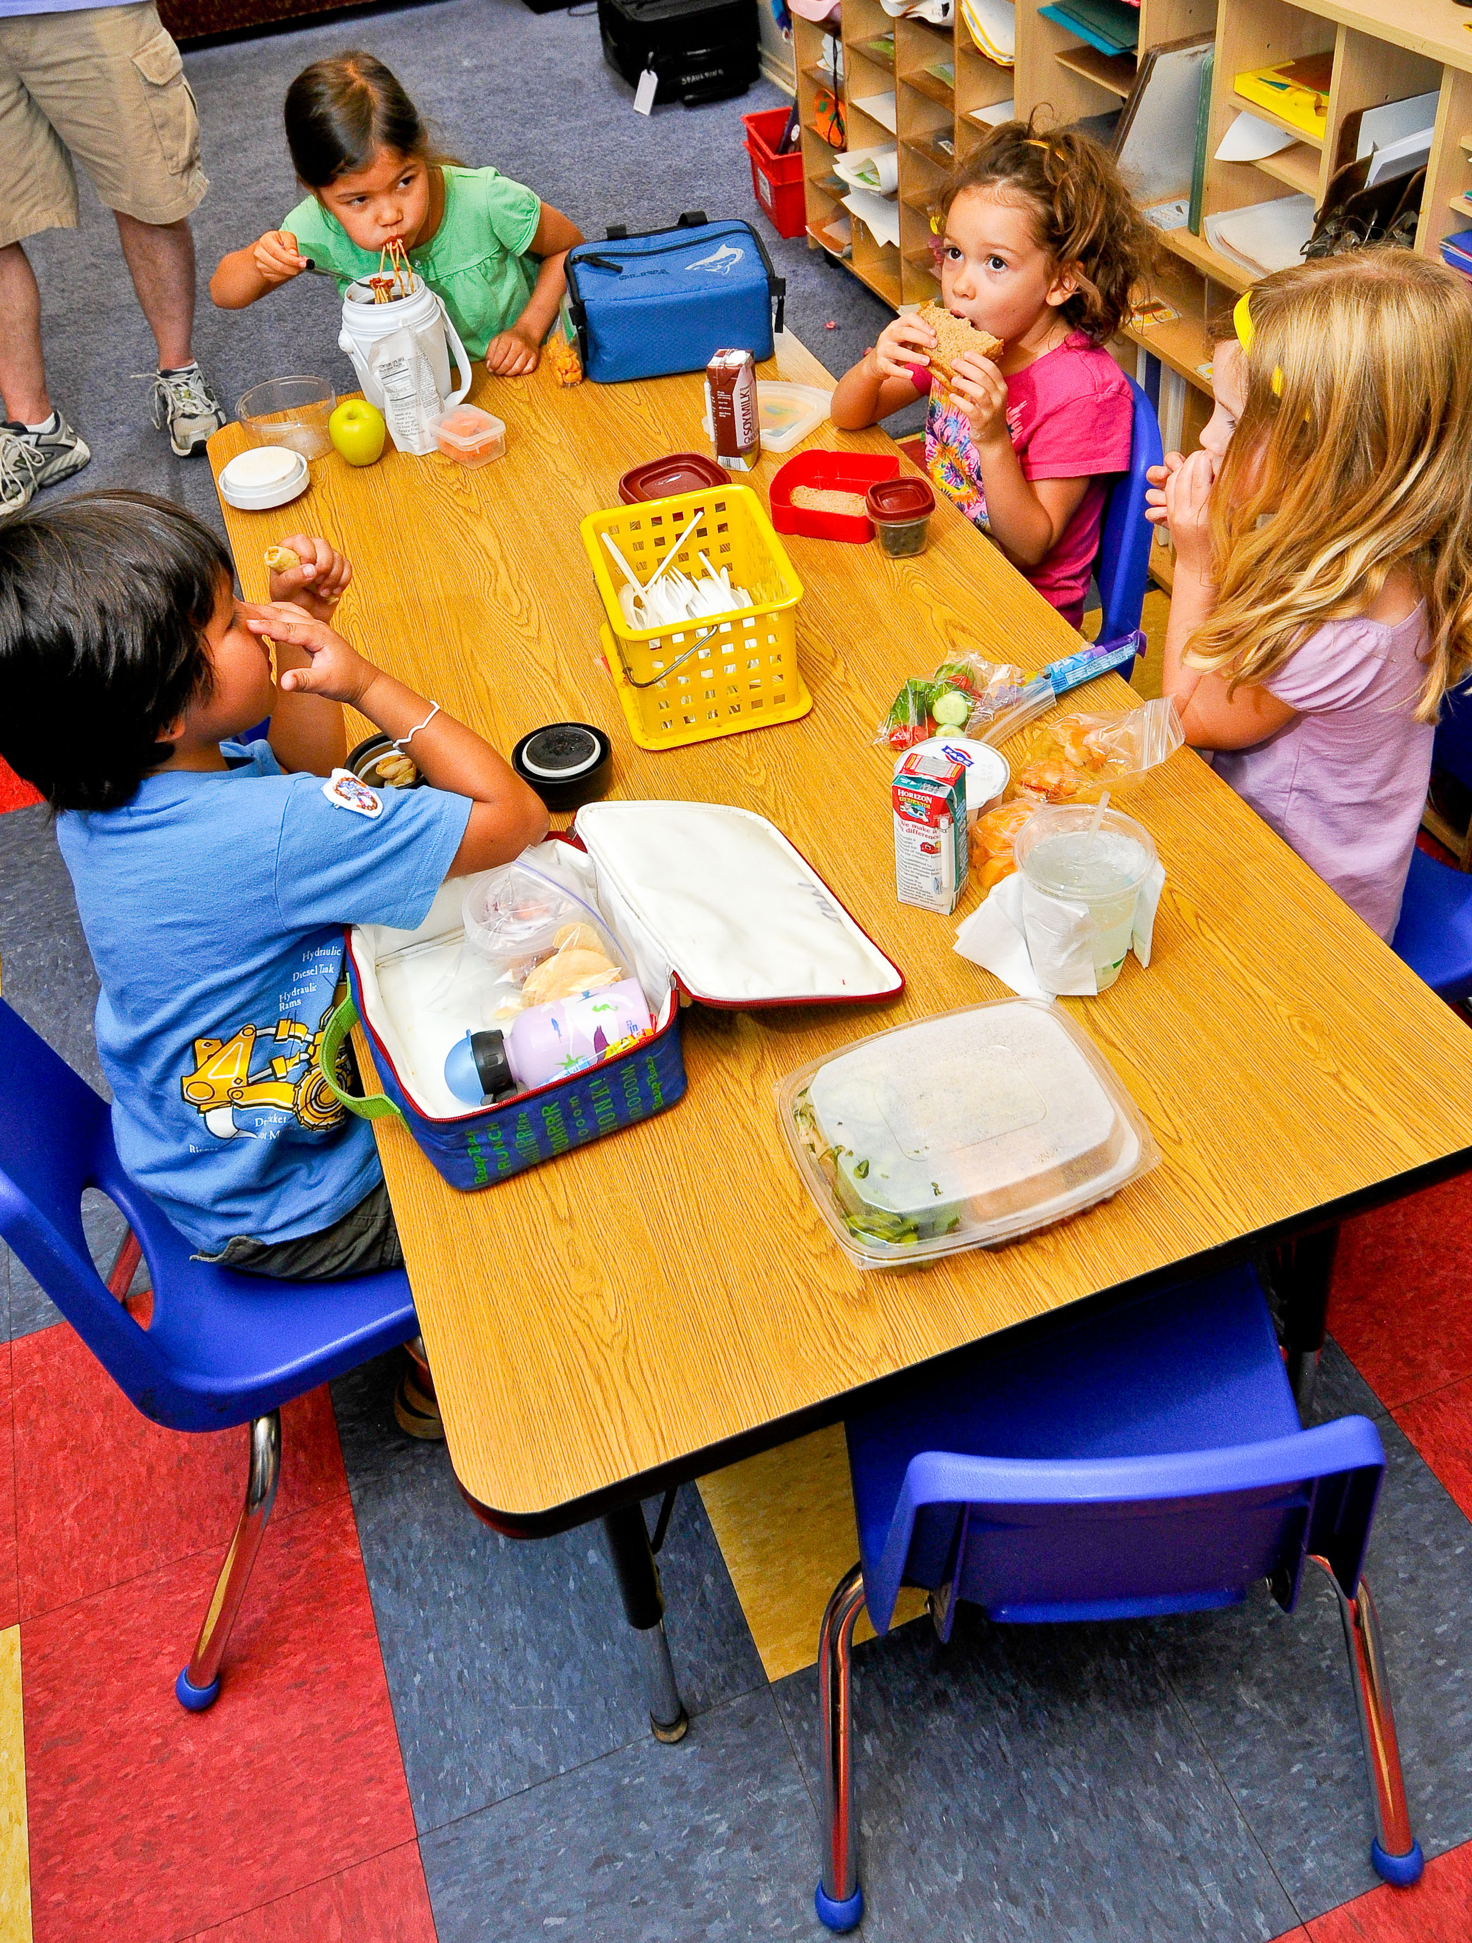

Twitter posts
Breastfed babies have lower risks of asthma, childhood obesity, and Type 2 #diabetes. Other benefits: http://ow.ly/We1xa #breastfeeding
#Breastfeeding has health benefits for babies AND mothers. Learn the facts: http://ow.ly/We1JO #childhealth
#Breastfeeding has health benefits for both babies and mothers! Be a champion: http://ow.ly/We1Wm #childhealth
Does [state abbreviation]’s proposed Child Care Plan support #breastfeeding for all? Find out: <enter shortened URL here> #childhealth
#ChildCare should support women who want to #breastfeed. Does your child care plan support them? <enter shortened URL here> #childhealth
.@USDA proposed new #nutrition standards for #ChildCare settings. Does [state abbreviation]’s proposed plan back the new standards? <enter shortened URL>
Find out how #ChildCare providers can support moms who want to #breastfeed: http://ow.ly/We31g #childhealth
Healthy eating habits begin in early childhood. Tips on how to feed the kids in your care: http://ow.ly/We35B #childcare #childhealth
.@USDA proposed new, improved #nutrition standards for #ChildCare settings. Some important changes: http://ow.ly/We3fQ #childhealth
Healthy food fuels brain development in young children. Best practices for serving up nutritious meals: http://ow.ly/We3ln #nutrition
All children deserve nutritious meals! Here’s what mealtime should look like in #ChildCare: http://ow.ly/We3uV #nutrition
#ChildCare is a great place to establish healthy eating habits. Ways to encourage healthy eaters: http://ow.ly/We3IA #nutrition
Is your young one in #ChildCare? Meals and snacks should follow these #nutrition standards: http://ow.ly/We3V4 #childhealth

Physical Activity
Facbook Posts
- Post text: Children ages 1 to 3 need 60-90 minutes of physical activity every day. URL: http://www.fns.usda.gov/sites/default/files/activeplaytips.pdf
Post title: Nutrition and Wellness Tips for Young Children
Post description: Provider Handbook for the Child and Adult Care Food Program
Image to add: 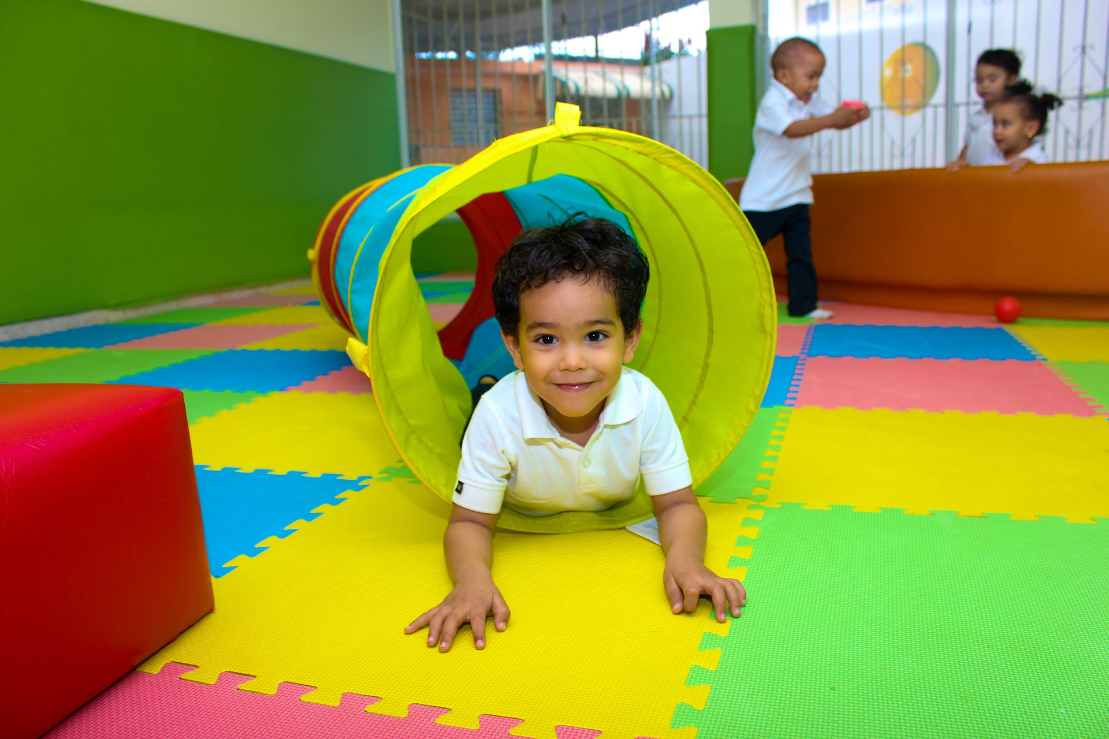
- Post text: Children ages 1 to 3 need 60-90 minutes of physical activity per day. Does [state name]’s proposed Child Care plan make active play for all children a priority?
URL: __________
Post title: (state’s) Proposed Child Care Plan
Description: TBD

- Post text: Children ages 1 to 3 need 60-90 minutes of physical activity every day. Learn more about active play >
URL: https://wicworks.fns.usda.gov/wicworks//Topics/TipsPlay.pdf
Post title: Healthy Tips for Active Play
Post description: Encourage your child to play actively several times each day.
Image to add: 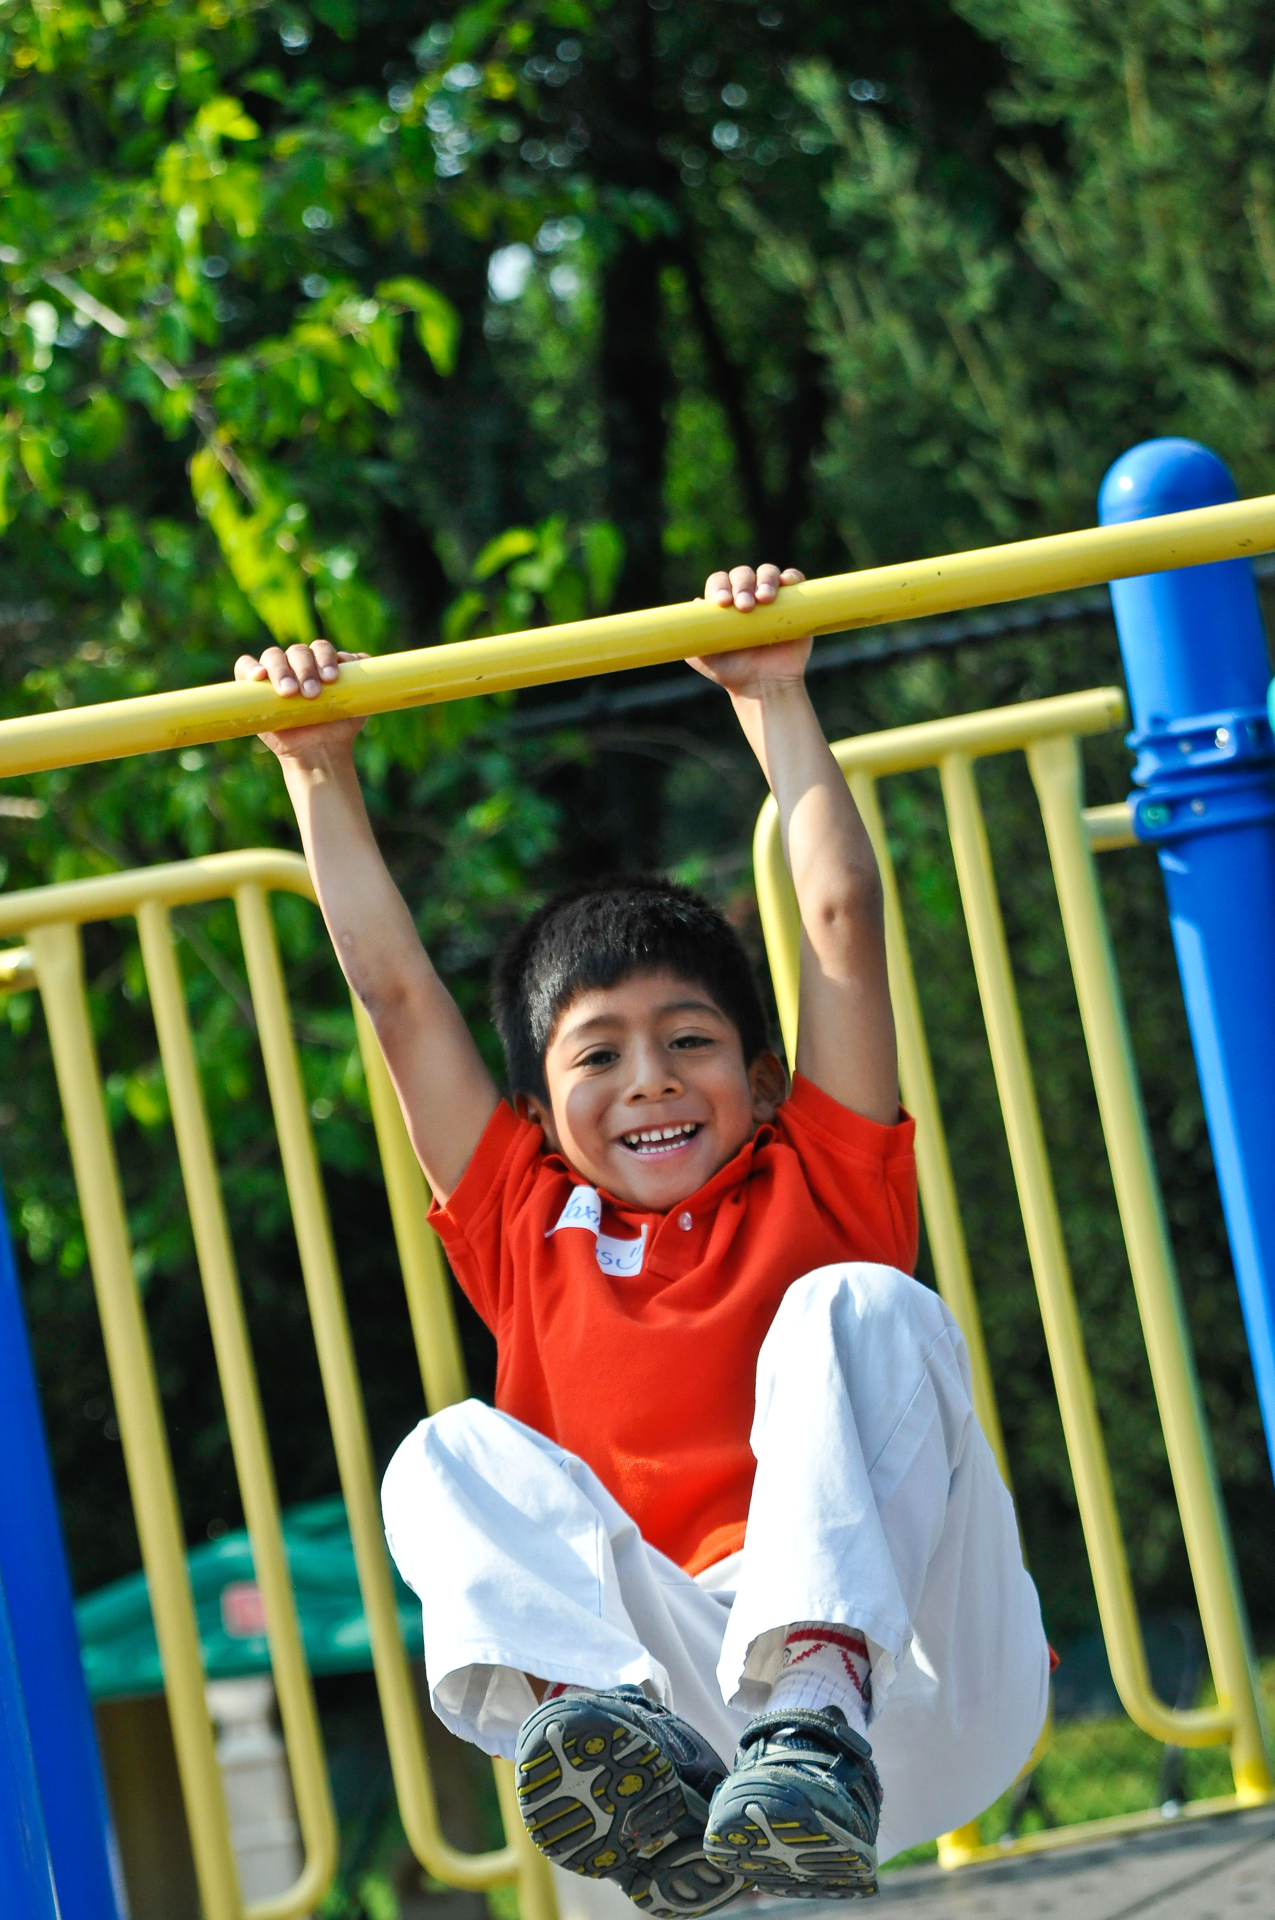
- Post text: Even babies need exercise! Child care providers should give infants some tummy time a couple of times a day.
URL: https://healthykidshealthyfuture.org/5-healthy-goals/get-kids-moving/
Post title: (default)
post description: (default)

- Post text: Learn more about physical activity requirements for young children.
URL: https://wicworks.fns.usda.gov/wicworks//Topics/TipsPlay.pdf
URL: https://wicworks.fns.usda.gov/wicworks//Topics/TipsPlay.pdf
Post title: Healthy Tips for Active Play
Post description: Encourage your child to play actively several times each day.
Image to add:
- Post text: Children ages 3-5 need 90-120 minutes of active play every day.
URL: http://www.fns.usda.gov/sites/default/files/activeplaytips.pdf
Post title: Nutrition and Wellness Tips for Young Children
Post description: Provider Handbook for the Child and Adult Care Food Program
Image to add:
- Post text: How can you raise a physically active child? Check out these tips >URL: https://wicworks.fns.usda.gov/wicworks//Topics/TipsPlay.pdf
Post title: Healthy Tips for Active Play
Post description: Encourage your child to play actively several times each day.
Image to add:
- Post text: Children ages 3-5 need 90-120 minutes of physical activity every day. Does [state name]’s proposed Child Care Plan make active play for all children a priority?
URL: ___________
Post title: (State)’s Proposed Child Care Plan
Post description: TBD

- Post text: Children who are active are more likely to develop strong bones, improve brain development, and stay at a healthy weight. More benefits of physical activity >
URL: https://healthykidshealthyfuture.org/5-healthy-goals/get-kids-moving/

- Post text: Most young children needs lots of physical activity. Check out these best practices for the all children in your care >
URL: https://healthykidshealthyfuture.org/5-healthy-goals/get-kids-moving/

Twitter posts
Children ages 1 to 3 need 60-90 minutes of physical #activity every day: http://ow.ly/We8j6 #childhealth <add image to tweet>
Does [state abbreviation]’s proposed Child Care plan make active play for all children a priority? http://ow.ly/We8j6 #childhealth
Children ages 1 to 3 need 60-90 minutes of #physicalactivity every day. Tips for active play: http://ow.ly/We8Pl #childhealth
Even babies need exercise! #ChildCare providers should give infants tummy time a couple of times/day: http://ow.ly/We8Xq #childhealth
Learn more about activity requirements for young children: http://ow.ly/We96v #physicalactivity #childhealth <add image to tweet>
Children ages 3-5 need 90-120 minutes of active play every day: http://ow.ly/We9iP #physicalactivity #childhealth
How can you raise a physically active child? Check out these tips > http://ow.ly/We9F5 #childhealth #physicalactivity
Does [state abbreviation]’s proposed #ChildCare Plan make active play for all children a priority? <insert shortened URL here> #physicalactivity
Active children are more likely to develop strong bones, improve brain development, and stay at a healthy weight: http://ow.ly/Wea8X
Most young children needs lots of #physicalactivity. Best practices to get kids moving in #ChildCare: http://ow.ly/Weamz #childhealth

Keeping all Children Healthy
Facebook Posts
- Post text: Children who log lots of screen time are more likely to be at risk for serious diseases like diabetes when they get older. Best practices for limiting electronics, starting with babies >
URL: https://healthykidshealthyfuture.org/5-healthy-goals/reduce-screen-time/

- Post text: One in five children between the ages of 2 and 5 are overweight and at risk for developing long-term health conditions. Here’s how we can make sure all kids grow up happy and healthy:
URL: https://healthykidshealthyfuture.org/5-healthy-goals/

- Post text: Children ages 2 to 5 who are overweight or obese are five times more likely to be obese adults. Find out how to help the children in your life maintain a healthy weight.
URL: http://www.heart.org/HEARTORG/GettingHealthy/HealthierKids/ChildhoodObesity/Preventing-Childhood-Obesity-Tips-for-Parents-and-Caretakers_UCM_456118_Article.jsp

- Post text: Children who are overweight or obese are more likely to develop heart disease, type 2 diabetes, cancer, and other diseases. Does your state’s proposed Child Care Plan address healthy active living?
URL: __________
Post title: (State’s) Proposed Child Care Plan
Post description: TBD

- Post text: One in five children between the ages of 2 and 5 are at an unhealthy weight. Child care providers can help fight the trend by encouraging kids in their care to be active.
URL: https://healthykidshealthyfuture.org/5-healthy-goals/
Twitter Posts
Best practices for limiting screen time and electronics, starting with babies > http://ow.ly/WebWs #childhealth #screentime
1 in 5 children between ages 2 and 5 are overweight and at risk for developing long-term health issues: http://ow.ly/Wec8d #childhealth
How to help the children in your life maintain a healthy weight: http://ow.ly/WechF #childhealth #healthykids
Does your state’s proposed #ChildCare Plan address healthy active living? <insert shortened URL here> #childhealth #healthykids
#ChildCare providers can help fight the #obesity trend by encouraging kids in their care to be active! 5 goals: http://ow.ly/WecMT

