**Social Media Share Kit  
Child Care Aware® of America  
2016 State Fact Sheets**

Copy and paste these posts into your social media channels for sharing. Don’t forget to tag Child Care Aware® of America (@USAchildcare) and use the hashtag #FacesofChildCare.

To use one of the graphics included in this package, right click on the graphic and “save as picture”. Then upload to your social media post! Text in green is meant as an instruction or note – do not copy it into your post.

**Included in this share kit:**

* Facebook posts
* Twitter posts
* Instagram posts
* Graphics (included throughout posts)

**FACEBOOK**

**Post**: <share image first>  
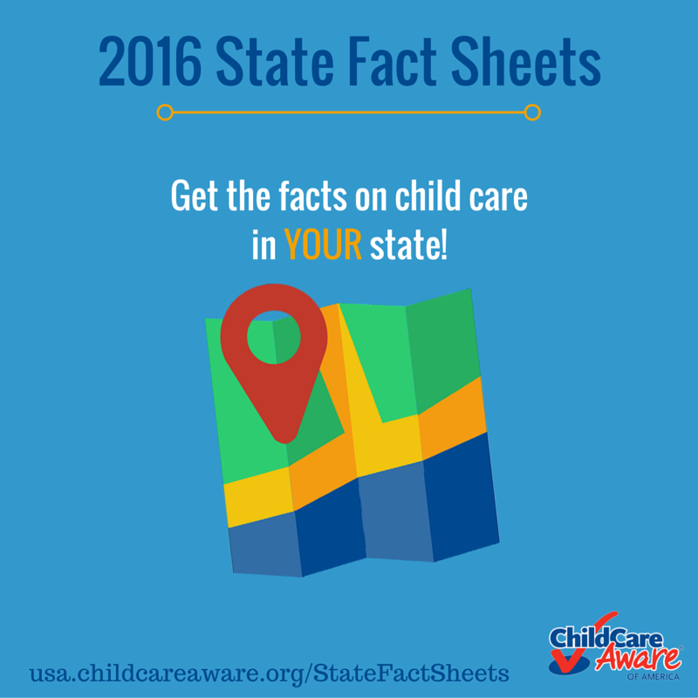  
**Post text:** The Child Care Aware of America (link to @USAchildcare on Facebook) 2016 State Fact Sheets are out! Get stats on child care in your state at: <http://usa.childcareaware.org/statefactsheets>

**Post**: usa.childcareaware.org/statefactsheets   
**Post text:** Use statistics from your state to promote informed, necessary policy changes!  
**Image**: <insert/change image to the one below>

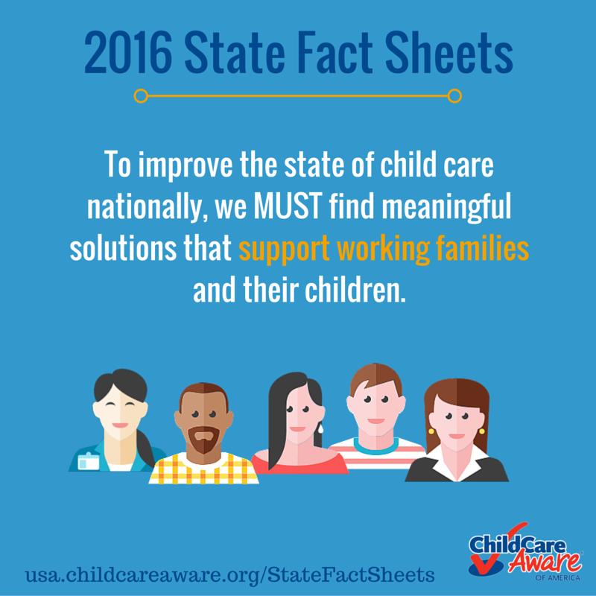

**Post title and description:** leave text that automatically pulls from the page as-is

**Post:** usa.childcareaware.org/statefactsheets **Post text:** Advocates need stats. Child Care Aware of America (link to @USAchildcare on Facebook) has them. **Image:** <insert/change image to the one below>

**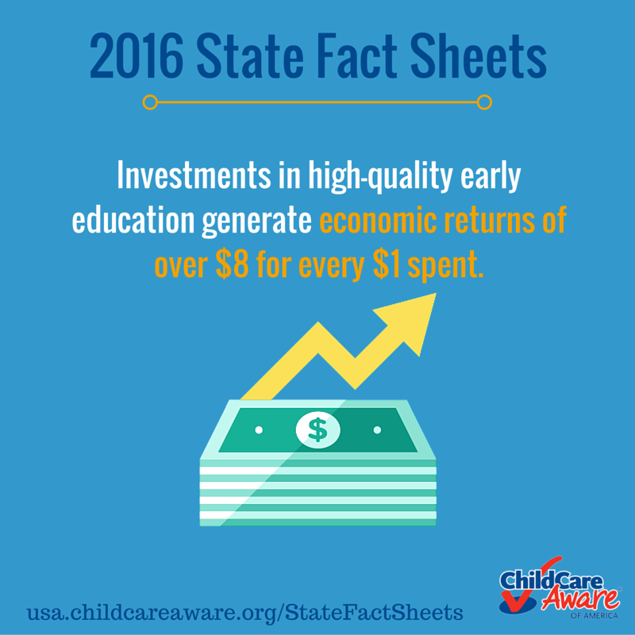  
  
Post title and description:** leave text that automatically pulls from the page as-is

**TWITTER**

What’s the #ChildCare landscape look like in <your state abbreviation>? @USAchildcare has the facts: <http://ow.ly/nG6c301NSS7> <insert image below>

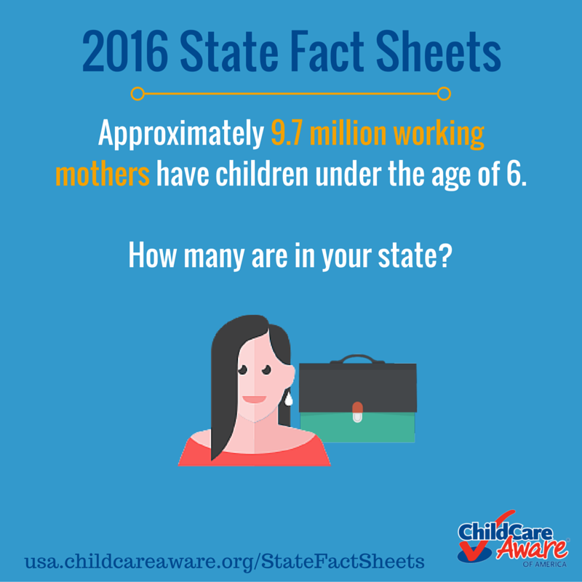

.@USAchildcare released the 2016 State Fact Sheets to help explain the complex #ChildCare landscape: <http://ow.ly/nG6c301NSS7>

States can assess the use, supply, and cost of ~~#~~ChildCare, the workforce, and the services provided by CCR&Rs: <http://ow.ly/nG6c301NSS7>

Approximately 9.7M working mothers have children under age 6. How many are in your state? <http://ow.ly/nG6c301NSS7>

Use the @USAchildcare fact sheets to guide decisions around #ChildCare programs and expenditures at the state level: <http://ow.ly/nG6c301NSS7>

**INSTAGRAM**

What does the #ChildCare landscape look like in <#YourStateHere>? @USAchildcare has the facts. <insert image below> #EarlyEd #ECE #EarlyLearning

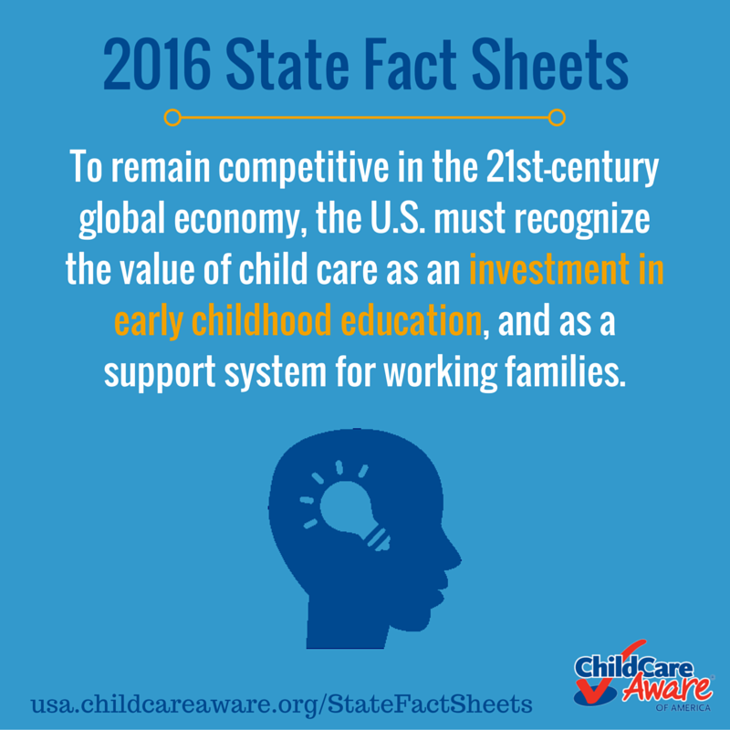

@USAchildcare released the 2016 State Fact Sheets to help explain the complex #ChildCare landscape in the United States. Advocates like YOU can use them to talk to your members of Congress! #TakeAction #Congress   
<insert image below>  
  


States can assess the use, supply, and cost of ~~#~~ChildCare, the workforce, and the services provided by CCR&Rs in the 2016 State fact Sheets from @USAchildcare. #CCRR #EarlyEd #ECE #EarlyLearning  
<insert image below>  
  
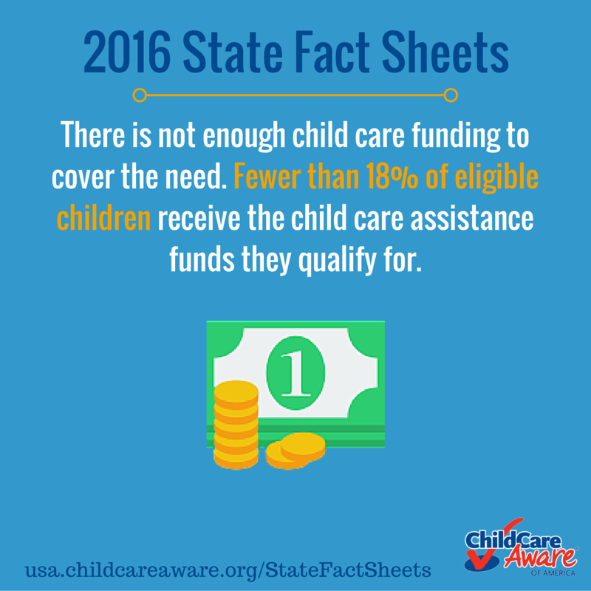

Approximately 2.2M individuals earn a living caring for children under age five. How many are in your state? #ChildCare #CCRR #EarlyEd #ECE #EarlyLearning  
<insert image below>

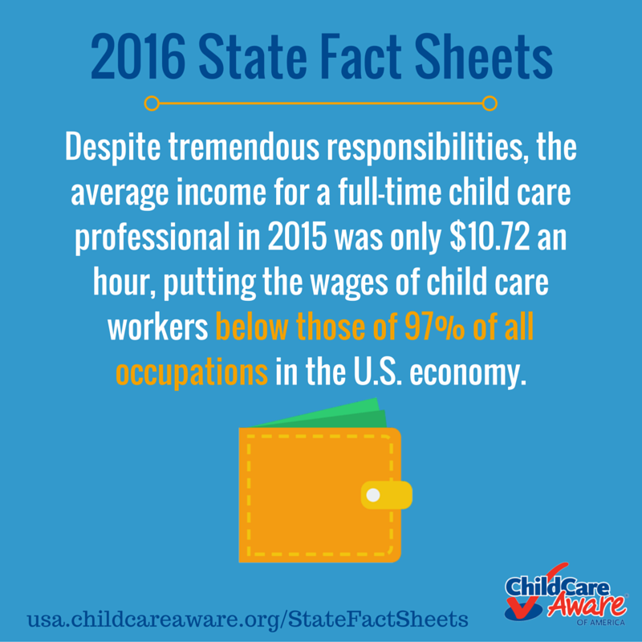

Use the @USAchildcare fact sheets to guide decisions around #ChildCare programs and expenditures at the state level. #TakeAction #CCRR #EarlyEd #ECE #EarlyLearning  
<insert image below>

